1. create table owner (owner_name varchar2(30), owner_NID number(20) primary key, email varchar2(40),a.id number(20));

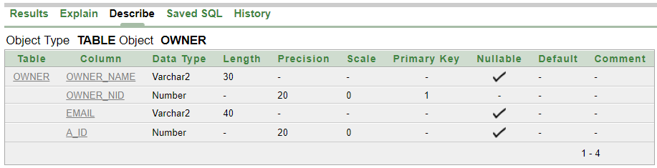

2. create table Location (a_id number(20) primary key,city varchar2(10), country varchar2(20));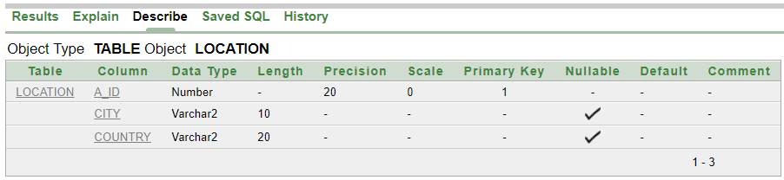

3. create table Coffee_Shop (licence number(35) primary key, cs_name varchar2(20),cs_address varchar2(30), owner_NID number(10));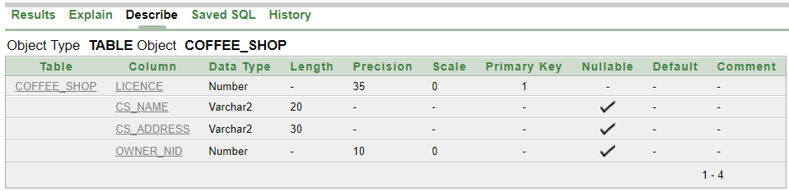

4. create table Brance (b_name varchar2(20),b_id number(20) primary key,b_address varchar2(20),licence number(35));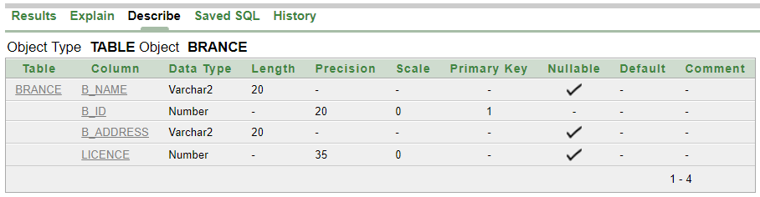

5. create table Employee(gender varchar2(10), role varchar2(20), e_id number(20), e_phone_no number(20),salary number(10),a_id number(20),b_id number(20));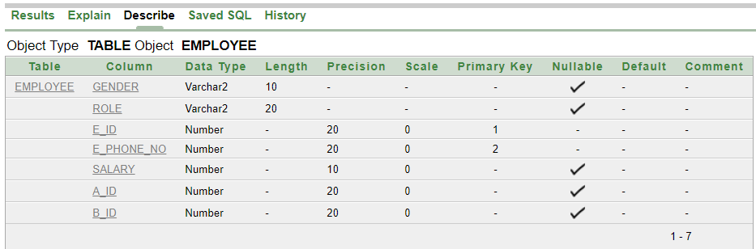

6. create table fk_b1 (b_name varchar2(20),b_id number(20) primary key,b_address varchar2(20),m_id number(10),m_phone_no number(20));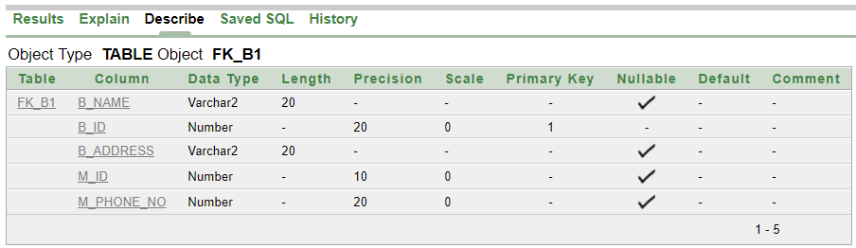

7. create table Manager(hiredate DATE,salary number(10),m_id number(10), m_phone_no number(20));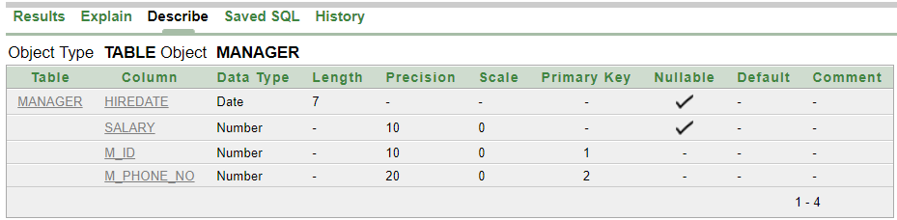

8. create table Chef (c_phone_no number(20),c_id number(10), C_name varchar2(20),salary number(10),m_id number(10), m_phone_no number(20));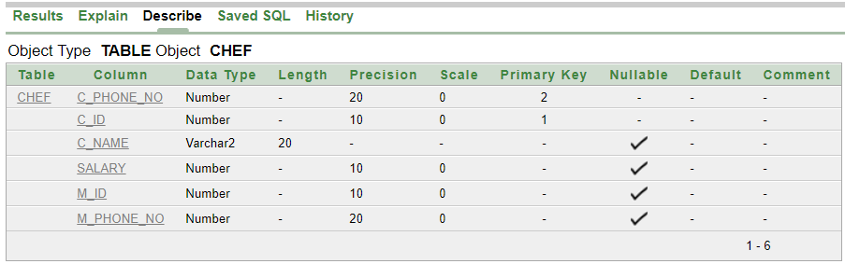

9. create table fk_c1(c_phone_no number(20),c_id number(10),i_id number(20));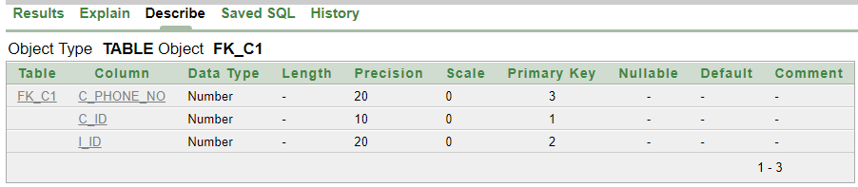

10. create table Item(i_id number(20) primary key,i_name varchar2(20),unit_price number(10),licence number(35));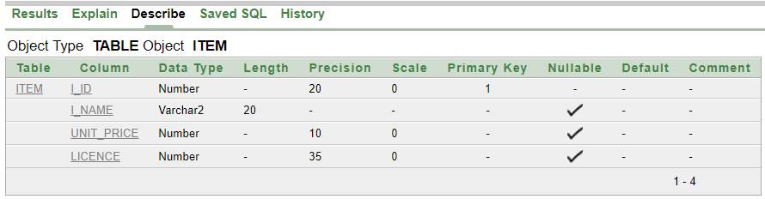

11. create table Customer(cust_id number(20) primary key, cust_name varchar2(15),licence number(35));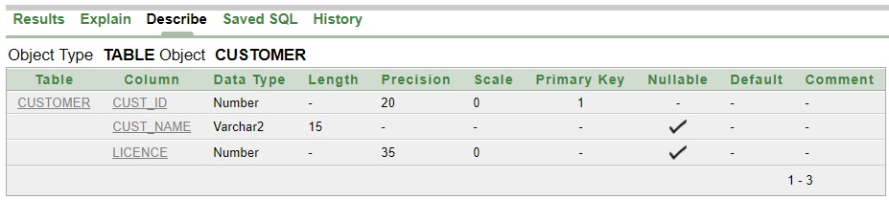

12. create table fk_cust1(cust_id number(20) primary key, cust_name varchar2(15),o_id number(10));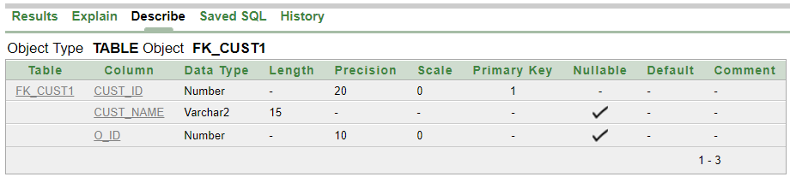

13. create table Order1(o_id number(10) primary key,o_date DATE, o_time number(10));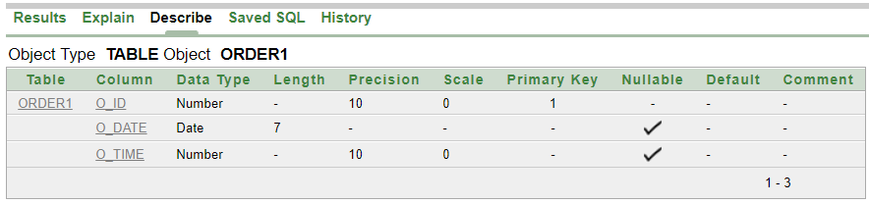

14. create table Bill (i_id number(20),c_id number(10),bill_id number(10),o_id number(10));

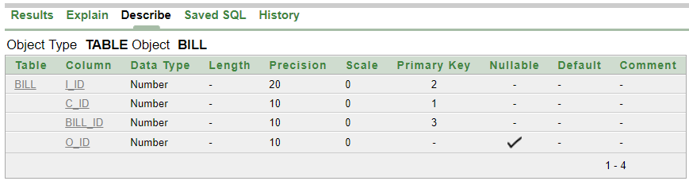

**QUERY WRITING:**

**Single Row Functions:**

Ques: Show the name of all customer.

Ans: select UPPER(cust_name) from Customer;

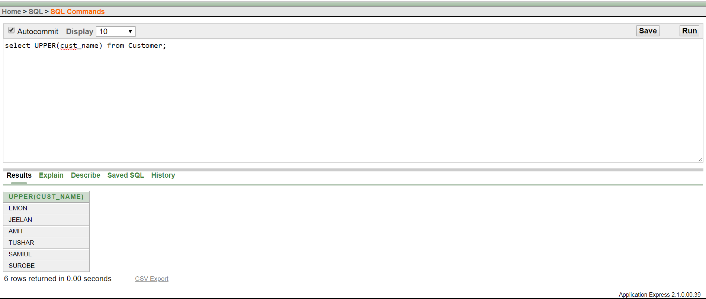

Ques: Display the place name in upper case.

Ans: select UPPER(city) from Location;

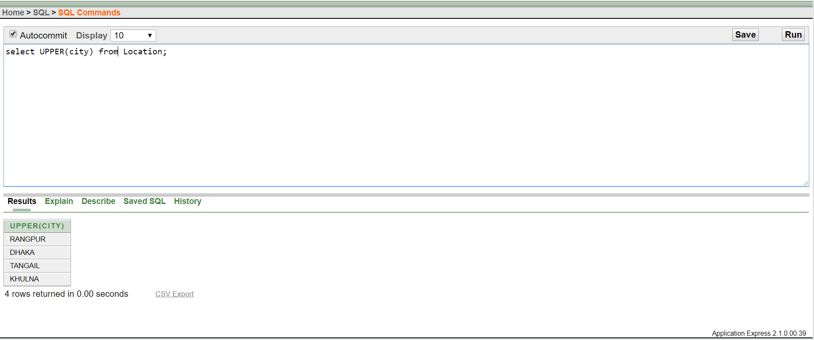

**Group Function:**

Ques: Find the average salary of the employees.

Ans: select AVG (salary) AS AVERAGE_EMPLOYEE_SALARY from Employee;

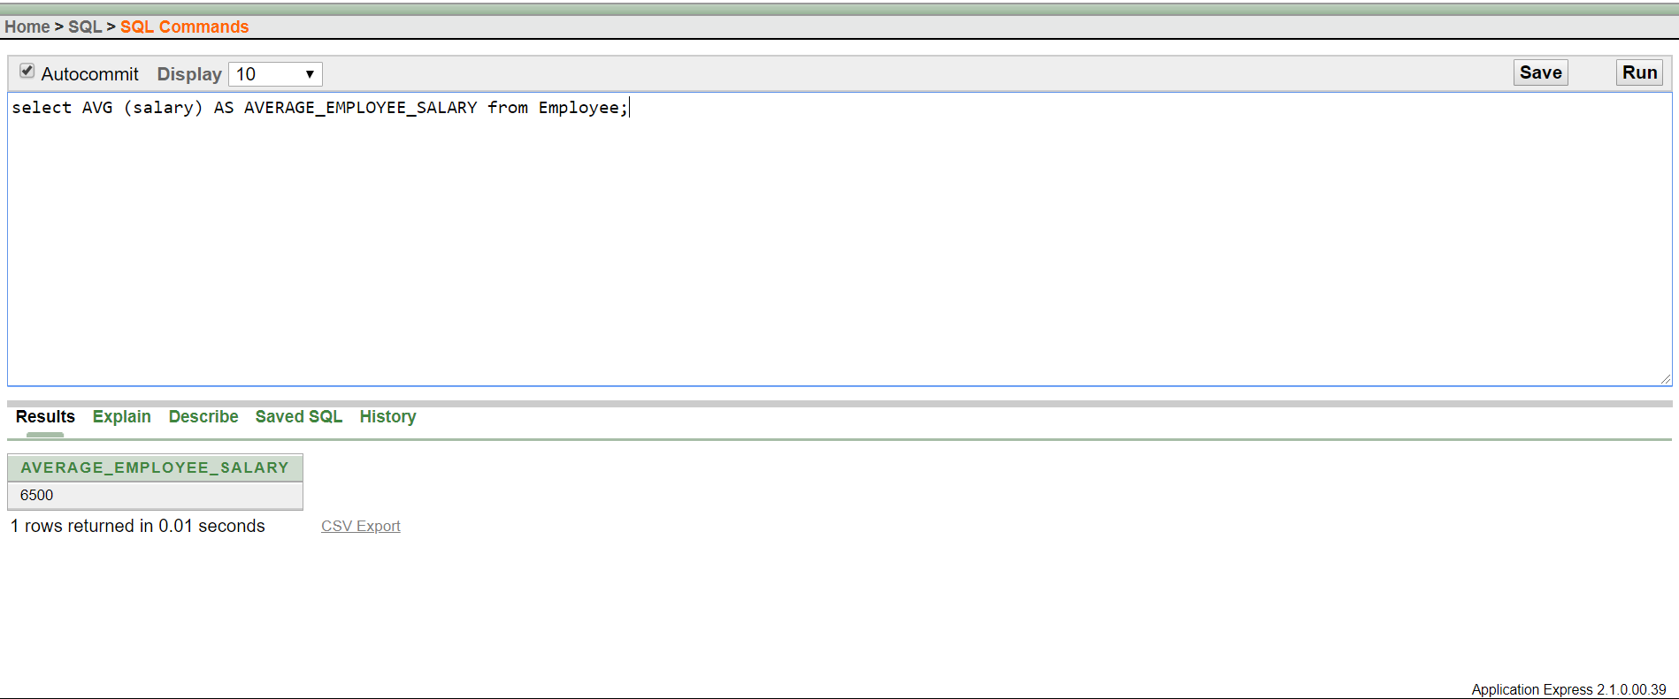

Ques: Find maximum salary of a manager.

Ans: select MAX(salary) as MAX_SALARY from Manager;

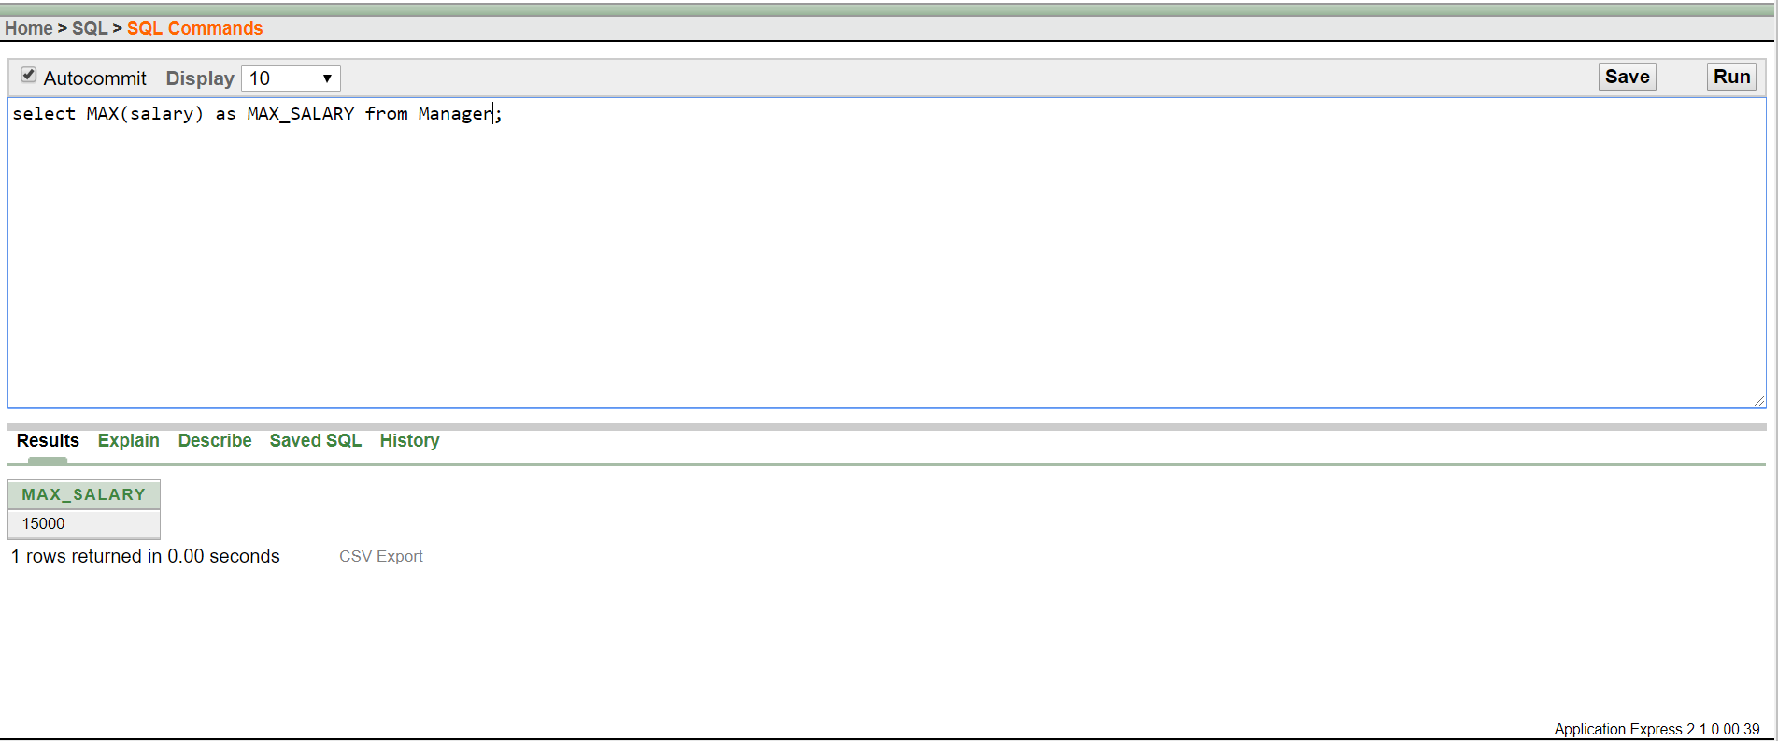

**Sub Query:**

Ques: Find the role of employees who get more salary then e_id= 075.

Ans: select role from Employee where salary > (select salary from Employee where e_ID=075);

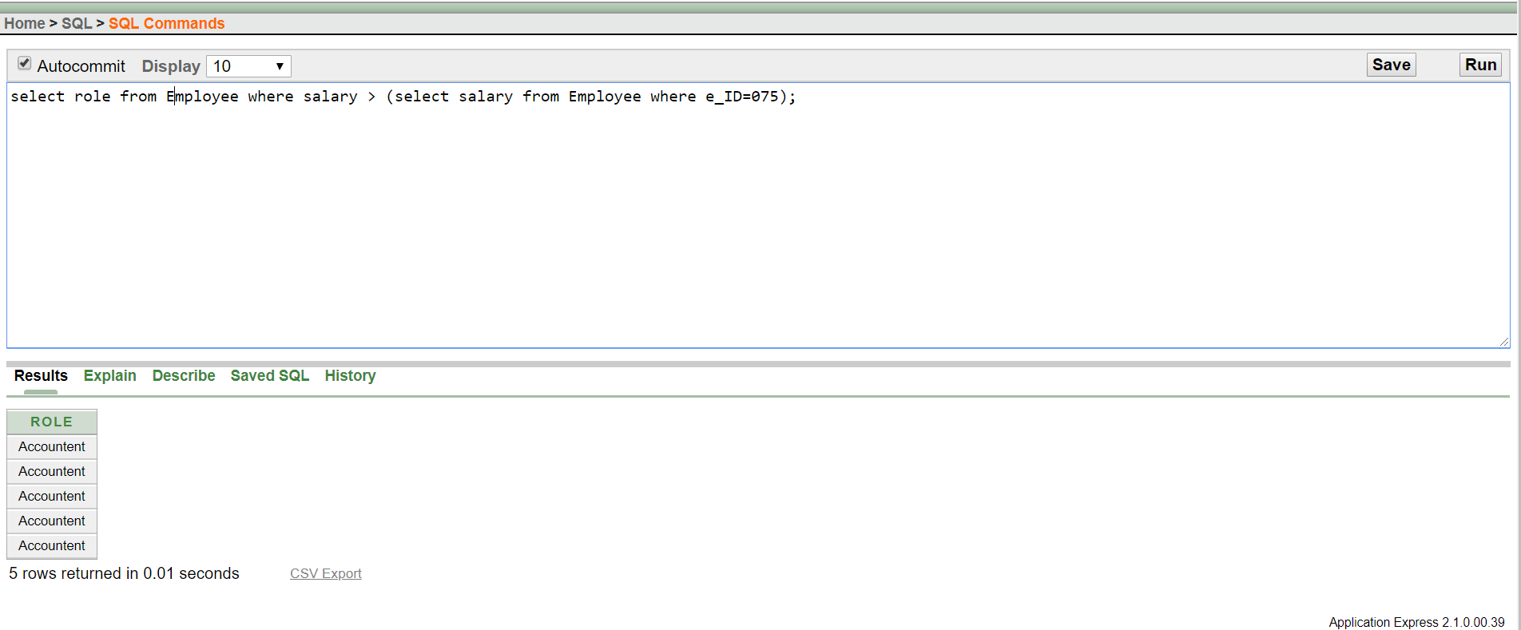

Ques: Find the name of items which prices is more then i_id=3005.

Ans: select i_name from Item where unit_price > (select unit_price from Item where i_ID=3005);

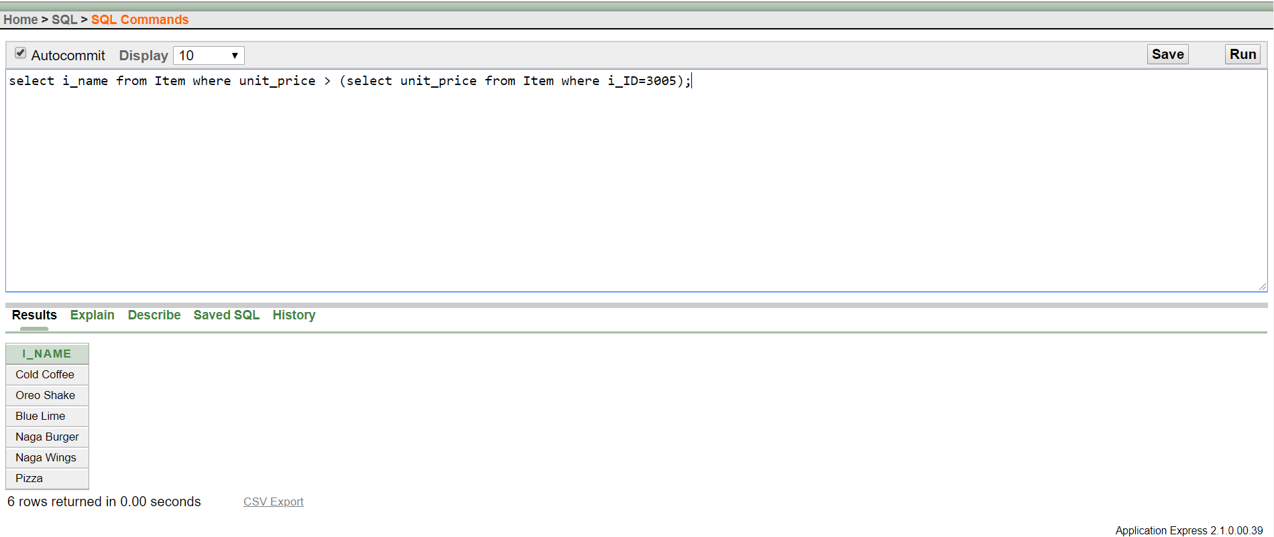

**Joining:**

Ques: Show the length of chef name and join their id and name.

Ans: select c_name,LENGTH(c_name) as "Length" ,CONCAT(c_id,c_name) as "Id and name" from chef;

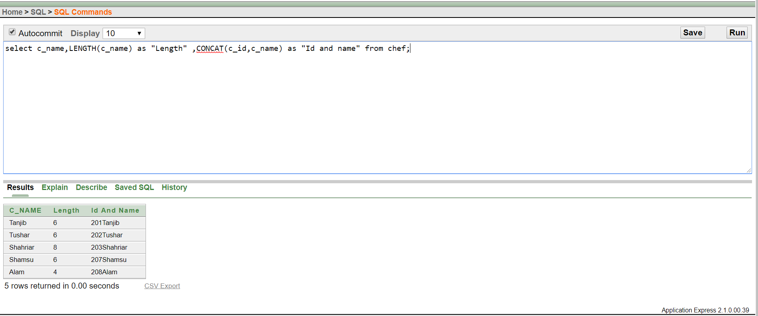

Ques: Display the manager ID and his chef name.

Ans: select Manager.m_id, Chef.c_name from Manager, chef where Manager.m_ID= Chef.m_ID;

